CALL FOR SUBMISSIONS:
Community engagement for inclusive rural transformation and gender equality
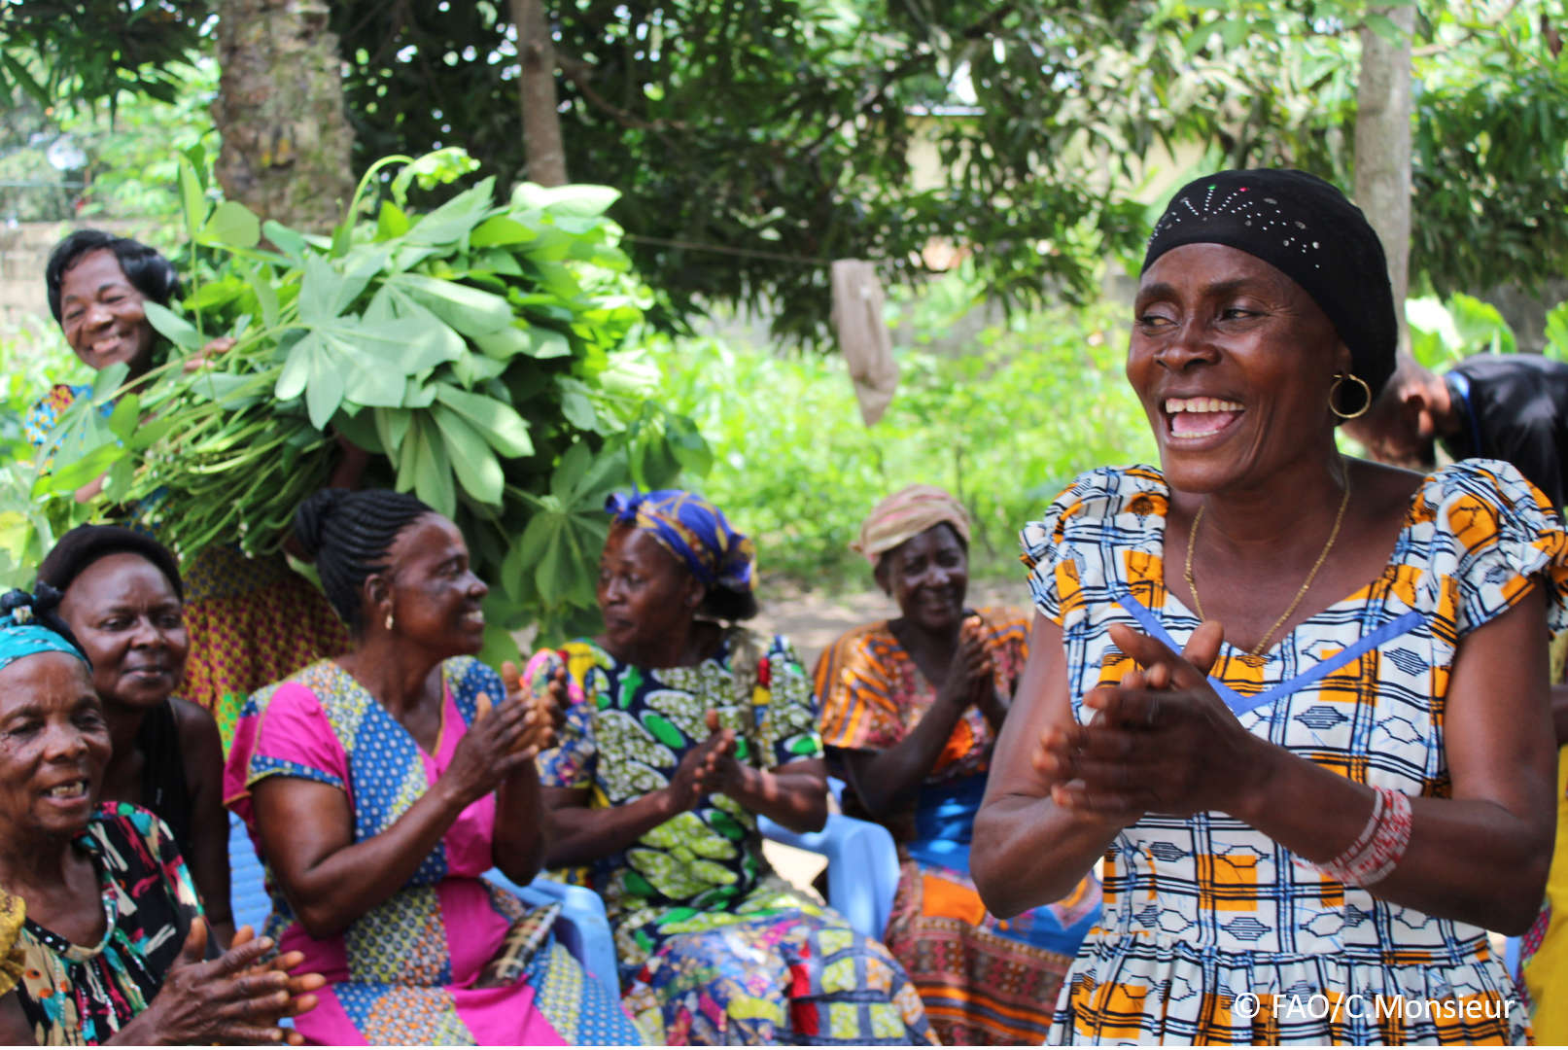
The objective of this call for submissions is to collect good practices, experiences, and lessons learnt on the use of community engagement for inclusive rural transformation and gender equality. The initiative, organized by the Rural Transformation and Gender Equality Division (ESP), seeks to gather insights from a diverse range of contributors, both within FAO and from external stakeholders. Its goal is to share knowledge, foster learning, and guide the scaling up of community engagement and community-led collective action to leave no one behind. The call builds on FAO's past efforts in this area, such as the Community Engagement Days series of webinars.
The call for submissions is open until 27 November 2024.

How to take part in this call for submissions:
To take part in this Call for submissions, please register to the FSN Forum, if you are not yet a member, or “sign in” to your account. Please review the topic note to understand the criteria we are considering for this call. If you wish to learn more about community engagement, you may refer to the background document. Once you have completed this submission template, upload it in the box “Post your contribution” on the call webpage, or, alternatively, send it to fsn-moderator@fao.org.
Please keep the length of submissions limited to 1,500 words and feel also free to attach relevant supporting materials.

Template for submissions

Contact person | Name: Sandra Misiribi  Organization/Unit: Good Health Community Programmes  Country:Kenya  Email address: sandra_misiribi@yahoo.com
Name/title of the good practice
Where is the good practice taking place? (Multiple selection allowed) | ☐ Europe and Central Asia  ☐ Latin America and the Caribbean  ☐ North Africa and Near East  ☐ Sub-Saharan Africa  ☐ Asia and the Pacific  ☐ North America  ☐ Global
Affiliation | ☐ Farmer and producer organizations  ☐ Trade Union  ☐ Informal community-based, farmer-based or self-help group  ☐ Research and academia  ☐ Government  ☐ Local/traditional authorities  ☐ Private Sector  ☐ Civil Society Organization  ☐ Intergovernmental Organization (e.g. UN system, World Bank)  ☐ Resource Partner/Donor  ☐ Other (please specify)  Grassroot women led self help group
In which sector(s) and context (s) have you used this community engagement good practice? (Multiple selections allowed) | ☐ Education  ☐ Health and Sanitation  ☐ Food production in agrifood systems (please also tick the sub-categories)  ☐ Crop cultivation  ☐ Fisheries and aquaculture production  ☐ Livestock  ☐ Forestry  ☐ Agroforestry  ☐ Horticulture  ☐ Apiculture (beekeeping)  ☐ Agroecology and sustainable farming practices  ☐ Soil and water management  ☐ Other: ____________  Agriculture  ☐ Post-production in agrifood systems (please also tick the sub-categories)  ☐ Processing and value addition  ☐ Marketing and retailing  ☐ Transporting  ☐ Food loss and waste  ☐ Packaging  ☐ Storage  ☐ Distribution  ☐ Other _________  ☐ Gender Equality  ☐ Climate Action  ☐ Citizenship and Governance  ☐ Social Protection  ☐ Humanitarian and protracted crisis  ☐ Conflict resolution, peace and resilience  ☐ Digital innovation  ☐ Other sector (please specify) _________
Who are the financial partners supporting this good practice, if applicable? | Funds exhausted
- In a few sentences, summarize your community engagement good practice.
Community engagement in inclusive rural development involves actively involving local residents in decision-making processes that affect their lives. This approach fosters collaboration among stakeholders, including government, NGOs, and community members, ensuring that diverse voices are heard. Key elements include:

Participation: Encouraging local involvement in planning and implementation.
Empowerment: Building capacity and skills within the community to promote self-sufficiency.
Sustainability: Developing projects that are environmentally and economically viable.
Equity: Ensuring marginalized groups have access to resources and opportunities.
Overall, effective community engagement leads to tailored solutions that reflect local needs and enhances social cohesion.

- What problem(s) or challenge(s) does your good practice aim to address through community engagement?
Addressing good community engagement can face several challenges, including:
Lack of Trust: Historical grievances or ineffective past engagements can lead to skepticism among community members.
Limited Resources: Insufficient funding and staffing can hinder outreach and the ability to sustain engagement efforts.
Diverse Needs and Interests: Balancing the varying priorities of different community groups can be complex and time-consuming.
Communication Barriers: Language differences, literacy levels, and varying cultural contexts can impede effective communication.
Inadequate Training: Lack of training for facilitators can result in poor engagement practices and misunderstandings.
Time Constraints: Community members may have limited time to participate due to work or personal commitments.
Resistance to Change: Some community members may resist new ideas or initiatives, preferring traditional methods.
Fragmented Community Structures: Disconnected community organizations can lead to inconsistent messaging and efforts.
Addressing these challenges requires intentional strategies, resources, and ongoing commitment from all stakeholders.
- Describe your good practice in more detail. Include the main guiding principles, the desired changes or outcomes you aim to achieve (Theory of Change), and the key phases of implementation.
Good community practice in rural transformation is guided by several key principles:Inclusivity: Engage all community members, especially marginalized groups, to ensure their voices are heard and needs are met.Sustainability: Focus on environmentally and economically sustainable practices that can be maintained over the long term.Empowerment: Build local capacities and skills to enable communities to take ownership of their development.Collaboration: Foster partnerships among community members, local organizations, and external stakeholders to resources and expertise.Cultural Sensitivity: Respect and incorporate local traditions, values, and knowledge into development initiatives.Adaptability: Be flexible and responsive to changing community needs and external circumstances.Transparency: Maintain open communication and accountability in decision-making processes to build trust.Evidence-Based: Use data and research to inform strategies and measure impact effectively.Participatory Approach: Involve the community in planning, implementation, and evaluation to enhance relevance and effectiveness.Holistic Development: Address multiple dimensions of community life, including economic, social, health, and education aspects, to ensure comprehensive growth.These principles can help create resilient and thriving rural communities
- Who are the key actors and stakeholders involved in the design and implementation of the good practice, and what are their respective roles? Consider local partners, government, local authorities, community radios, civil society, research, the private sector, etc. Grassroots women, CBOs, national and county government, farmers, NGOs, Media
- How does your intervention ensure inclusivity and equal and meaningful participation within the community.
Constitution of Kenya 2010
- By using community engagement, what results and impacts have your good practice achieved?
Sustainability and ownership of project, women, youth and PWD taking up leadership positions
- Among these results, has the good practice led to improvements in terms of gender equality, women’s empowerment, and/or social inclusion?
We have Kakamega Disability bill and auguration of board.
- What key challenges did you encounter while implementing the community engagement activities, and how did you address them?
Political interference, conflict of interest
- What are the key lesson learned from your community engagement good practice?
Bottom up approach is key for ownership and sustainability
- Has this practice been replicated in the same context or in different contexts?
Kakamega county we have 12 sub counties we have replicated in 2 sub counties remaining 9
- How sustainable are the results achieved by this good practice?
Kakamega Disability bill
- Based on the conversations FAO held during the Community Engagement days, a definition of community engagement for empowerment was proposed:

“Community engagement for empowerment and community-led collective action can be defined as an inclusive and participatory process that enables community members to become active agents of change in decisions affecting their lives, health, and environment. This process develops their capacity to achieve sustainable outcomes for improved rural livelihoods. Embracing a rights-based approach, it prioritizes the agency and participation of all community members, regardless of gender identity, sexual orientation, age, ethnicity, caste, socioeconomic status, political affiliation, migration status, or ability/disability. Indeed, inclusive approaches recognize the complexities of overlapping marginalization and discrimination that can exclude different community members from decision-making processes and implement strategies to foster their participation, agency and empowerment.”

We invite you to contribute to this definition. What would you add or change? Please share your thoughts, suggestions, and any additional elements you believe are crucial for a comprehensive understanding of community engagement approaches aimed at community-led collective action for inclusive rural transformation, people’s empowerment and gender equality.
Add: Community engagement for empowerment and community-led collective action involves a collaborative approach where community members actively participate in decision-making processes and take initiative to address their own challenges.

- Based on your experience, what gaps or areas for improvement still need to be addressed in the field of community engagement? Ownership and sustainability
- What do you think is FAO's role in the field of community engagement? How can FAO support and enhance interventions like yours, if applicable? Consider aspects such as policy advocacy, capacity development, funding, technical assistance, knowledge production and sharing, and fostering partnerships.

1.Capacity building.
2. Participatory Approaches
3. Empowerment Initiative
4. Collective vision and goals.
5. Knowledge Sharing
6. Collaboration and Partnerships
7. Monitoring and Evaluation
8. Crisis Response

Through these efforts, FAO aims to enhance community engagement, empower local populations, and promote sustainable agricultural practices, ultimately contributing to food security and rural development.
Link(s) to specific references about your good practice (e.g. reports, communication products, videos, articles) | Please include attachment(s) or add here link(s) to documents/videos/podcasts/other with specific references.Nil

The call for submissions is directly aligned with the thematic components of collective action within FAO's Programme Priority Areas (PPAs), specifically Better Life 1 (Gender Equality and Rural Women’s Empowerment), Better Life 2 (Inclusive Rural Transformation) and Better Life 3 (Agriculture and Food Emergencies).

